**UNIEATS**

**divplusplus**

**Client Feedback**

* Allow users to view and/or delete reservations (Done)

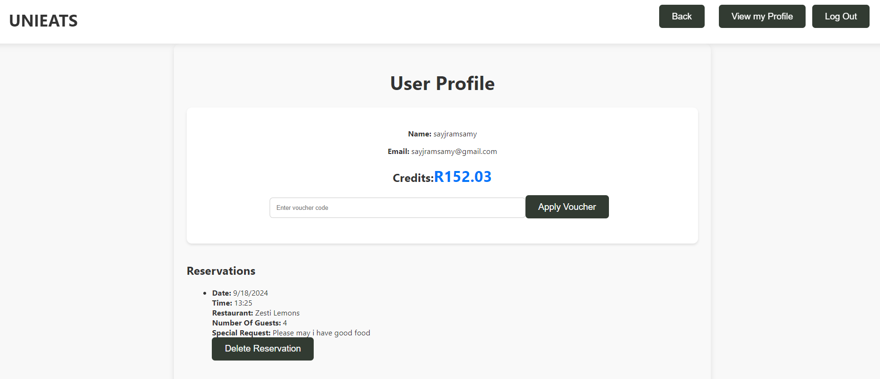

* Add previous reviews for a restaurant onto the restaurant’s homepage (Done – bottom right)

* Our voucher idea is good – allow the user to enter a voucher code to add more credits. The number of credits is based on the voucher code entered. (Done)

* Order status – send user a notification once order is ready (to mock restaurants, change order status after 30 minutes) then user clicks collected on the app once they collect their order (Done)

* Allow the user to view their previous reviews and reservations on the “User Profile” page (Done)

* For feature documentation include a bit about the technical aspect for each key feature. (Done)

[**Feature_Doc.docx**](Feature_Doc.docx)

* Populate menu database for each restaurant (Done)

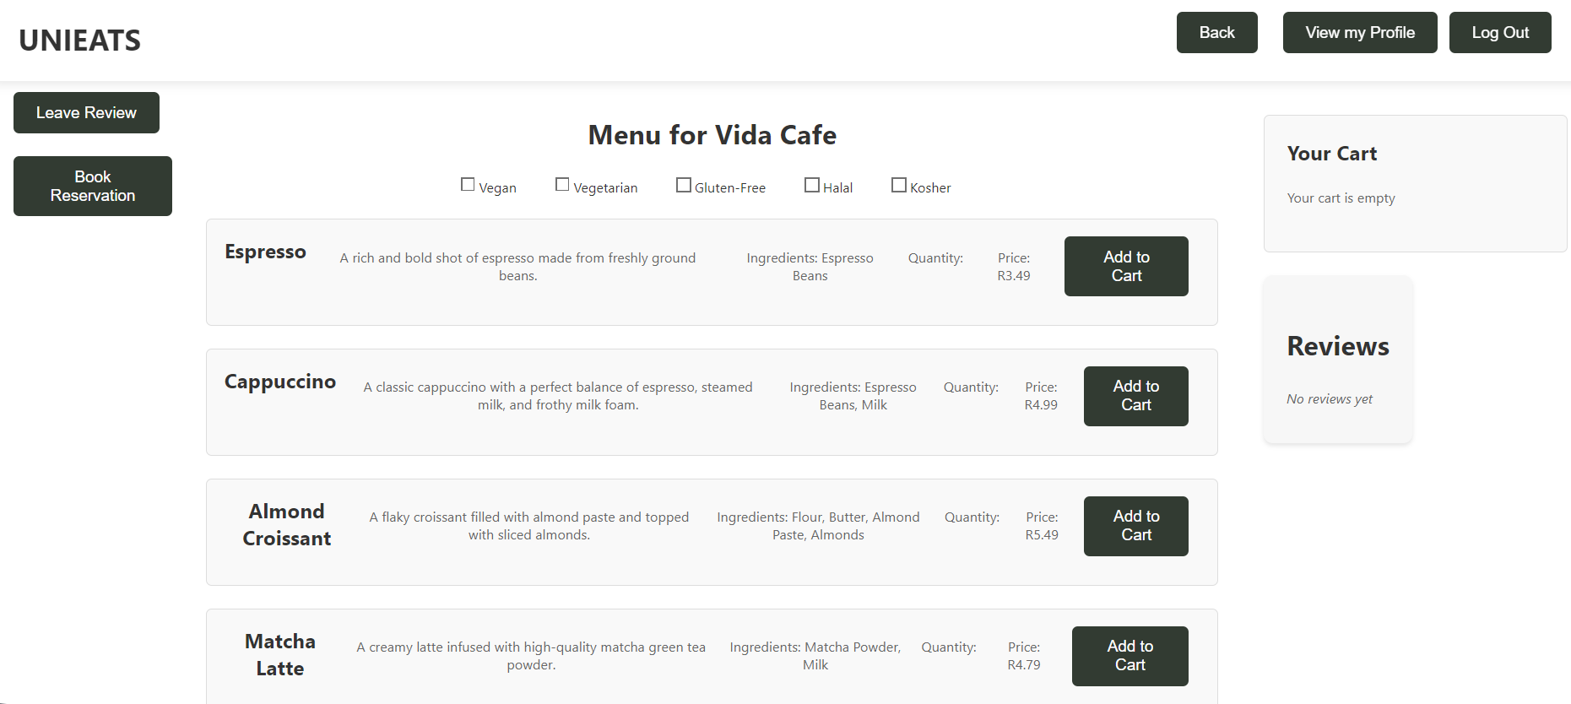

* Dietary management is not an API.
  + Spoke to client about this
  + Done in the frontend
  + Allow customers to change their dietary preferences in the instance that they are ordering for a friend with different dietary preferences
  + If a customer does change their dietary preferences, then it is an easy change for them
  + Dietary database does not exist rather an extra field is added in the database for each item as to which dietary preferences it is suitable for and shows when filtered.

**Feedback (not from client)**

* Our logo was unfavourable when shown to peers. (Done - Logo was changed)

* The website did not look good on a mobile phone, so we changed a bit of the CSS (Done - Changed CSS to improve look on mobile phone)
* The website did not allow a user to redeem a voucher code (Done – fixed bug)
* There is no way to go back to the previous page (Done – back buttons have been added)

